Home Page
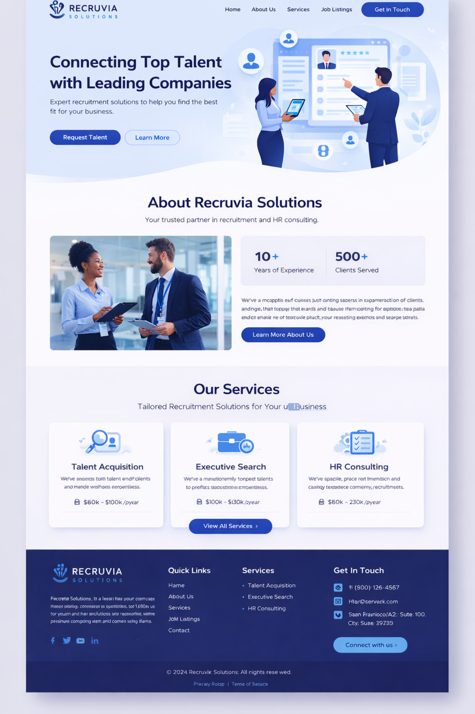

HERO SECTION (Top Banner)
Heading:
Connecting Top Talent with Leading Companies
Sub-text:
Recruvia Solutions provides reliable recruitment and HR solutions to help businesses find the right talent and professionals find the right opportunities.
Buttons:
- Request Talent
- Learn More

🔹 ABOUT RECRUVIA SOLUTIONS (Preview Section)
Heading:
About Recruvia Solutions
Sub-heading:
Your trusted partner in recruitment and HR consulting.
Content:
Recruvia Solutions is a professional recruitment firm committed to helping organizations hire skilled and qualified professionals. We work closely with companies to understand their hiring needs and connect them with candidates who match their requirements.
With industry knowledge and a strong talent network, we ensure a smooth and efficient hiring process for both employers and job seekers.
Highlights (Stats):
- 3+ Years of Experience
- 50+ Clients Served
Button:
Learn More About Us

🔹 OUR SERVICES SECTION
Heading:
Our Services
Sub-text:
Tailored recruitment solutions designed to support your business growth.

🔹 Permanent Staffing
We help companies identify, screen, and hire talented professionals who fit their organizational needs and culture.

🔹 Executive Search
Our executive search services focus on hiring senior-level professionals and leadership roles with precision and confidentiality.

🔹 HR Consulting
We provide HR consulting services to improve HR processes, workforce planning, and employee management practices.

Button:
View All Services

🔹 WHY CHOOSE RECRUVIA SOLUTIONS
Heading:
Why Choose Recruvia
- Experienced recruitment professionals
- Industry-specific hiring expertise
- Quick and reliable hiring process
- Quality-screened candidates
- Customized recruitment solutions

🔹 CAREER POINT SECTION (Highly Recommended Addition)
Heading:
Build Your Career with Recruvia Solutions
Content:
At Recruvia Solutions, we help professionals find suitable job opportunities across various industries. Whether you are a fresher or an experienced professional, submit your application and let us help you take the next step in your career.
Button:
Apply Now
(Navigates to your Application Page)

🔹 CALL TO ACTION SECTION
Heading:
Ready to Grow Your Team?
Content:
Get in touch with Recruvia Solutions today and let us help you find the right talent for your organization.
Button:
Contact Us

🔹 FOOTER CONTENT
About (Short):
Recruvia Solutions is a recruitment and HR consulting firm dedicated to connecting companies with the right talent and helping professionals build successful careers.
Quick Links:
- Home
- About Us
- Services
- Contact Us
Services:
- Permanent Staffing
- Executive Search
- HR Consulting
Contact Details:
Phone - 97140 27997
Email - hr@recruvia.in

Our Services

IT Services & Consulting
We deliver secure, scalable, and future-ready IT solutions that empower businesses to innovate and perform with confidence.
- Strategic IT consulting and advisory services
- Software, application, and system support
- Digital transformation and process optimization
👉 Transform your technology strategy.
[Request an IT Consultation]

Marketing Services
Our integrated marketing solutions help brands stand out, connect with the right audience, and achieve sustainable growth.
- Digital marketing, branding, and online presence management
- Promotional campaigns and targeted advertising
- Business development and market expansion support
👉 Elevate your brand visibility and impact.
[Talk to Our Marketing Experts]

Human Resource Consultancy & HR Solutions
We offer comprehensive HR consultancy services designed to build high-performing teams and compliant, people-centric organizations.
- Recruitment and strategic staffing solutions
- Payroll management and statutory compliance support
- Training and leadership development programs
- HR policy formulation, performance management, and organizational development
👉 Build a stronger workforce with confidence.
[Schedule an HR Consultation]

Ready to Grow Your Business?
Partner with us for expert-driven solutions tailored to your organization’s goals.
[Get in Touch] | [Request a Free Consultation]
